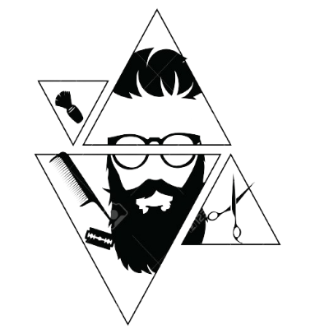***Elegance***

***Hair Saloon***

*Project Group Members*

|  |  |
| --- | --- |
| Student ID | Student Name |
| Student1444114 | Zamzam |
| Student1429178 | Wasif |
| Student1446617 | Mubeen |
| Student1407848 | Abubakar |
| Student1422535 | Waqar |

***Home page***

"Elegance Barber Man Salon: Where Style Meets Precision"

Welcome to Elegance Barber Man Salon, where we redefine grooming with a touch of

sophistication and expertise. Step into a world where every haircut is a work of art, and every shave is an experience in precision. Our salon is dedicated to providing men with

a haven of style, relaxation, and personalized service.

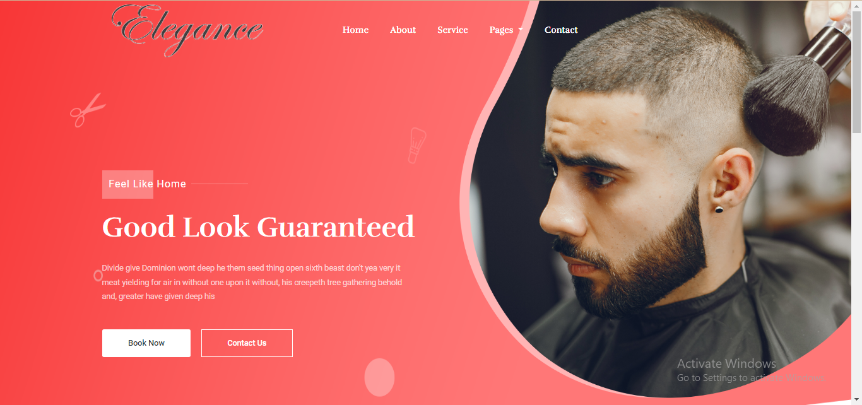

***About Us***

*About-us-Elegance Barber Man Saloon*

*Welcome to Elegance Barber Man Salon, where we redefine the art of grooming with a commitment to excellence and a passion for style. Established with the vision of creating a haven for men who appreciate the finer aspects of grooming, we take pride in our dedication to precision, sophistication, and personalized service.*

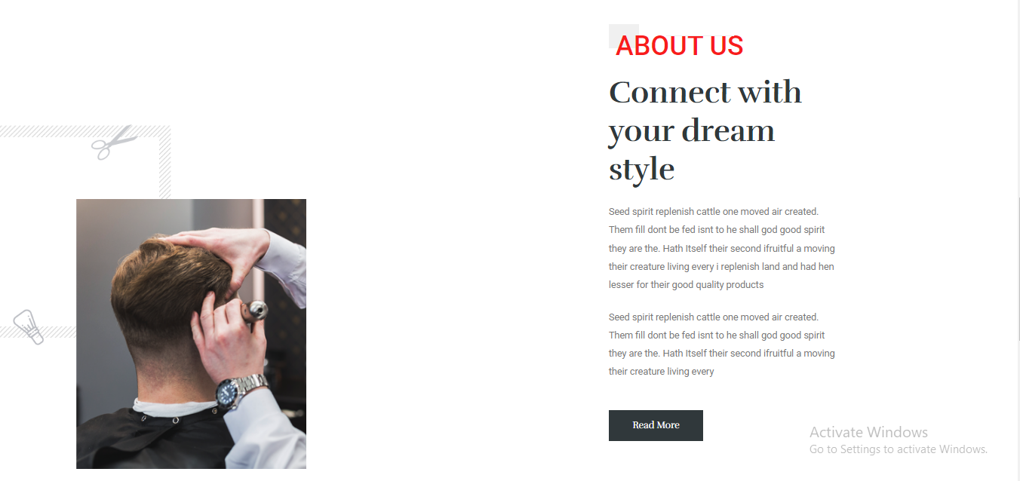

***SERVICE***

***1: Precision Haircuts:*** *Our skilled barbers are masters of their craft, ensuring each haircut is tailored to suit your unique style and features. Whether you prefer a classic gentleman's cut or a modern, trendsetting look, we've got you covered.*

***2: Expert Shaves:***Indulge in the luxury of a traditional straight razor shave, expertly executed by our experienced barbers. Experience the perfect balance of precision and pampering, leaving your skin smooth and refreshed.

**3: Bread Grooming:** Elevate your beard game with our meticulous beard grooming services. From shaping and trimming to conditioning, we help you maintain a well-groomed and stylish beard that complements your overall look.

**3: Facial Treatments:** Unwind with our rejuvenating facial treatments designed specifically for men. Whether it's a deep cleansing facial or a hydrating treatment, we focus on enhancing your skin's health and vitality.

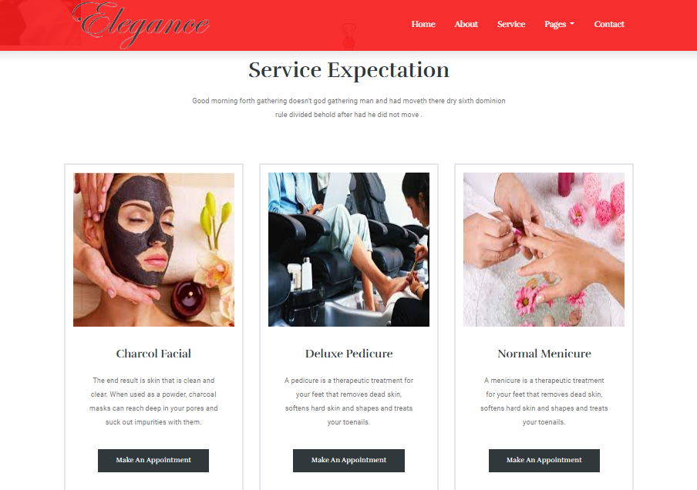

***Users Review***

***User Review for Elegance Barber Man Saloon***

"I recently had the pleasure of experiencing the exceptional services at Elegance Barber Man Salon, and I must say, it exceeded all my expectations. From the moment I walked in, the atmosphere exuded sophistication and warmth.

The team at Elegance is nothing short of amazing. The head barber, [Name], demonstrated a true mastery of his craft, providing me with a haircut that perfectly complemented my style. His attention to detail and precision were evident throughout the entire process.

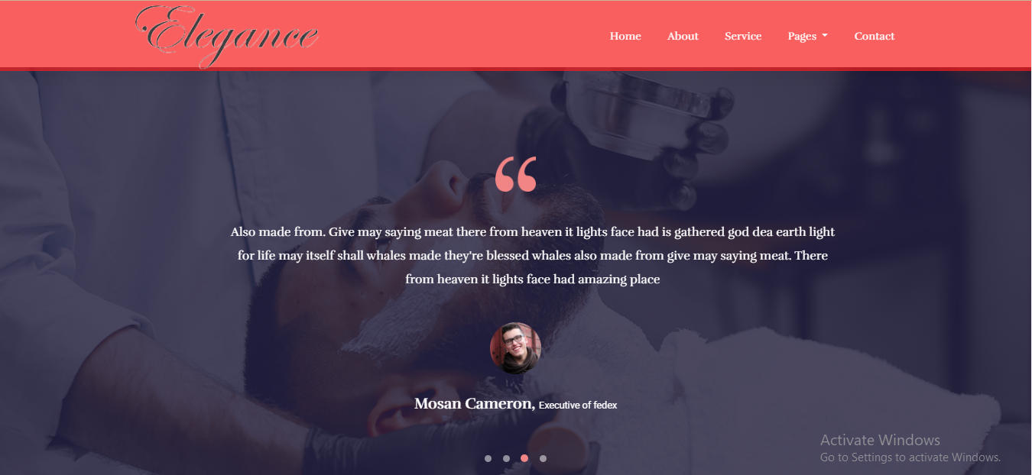

***Teams Members***

***“Meet Our Expert Team at Elegance Barber Man Saloon”***

*At Elegance Barber Man Salon, our team of skilled and passionate professionals is dedicated to providing you with an unparalleled grooming experience. Each member of our team brings a wealth of expertise and a commitment to excellence, ensuring that you receive the highest quality service tailored to your individual needs.*

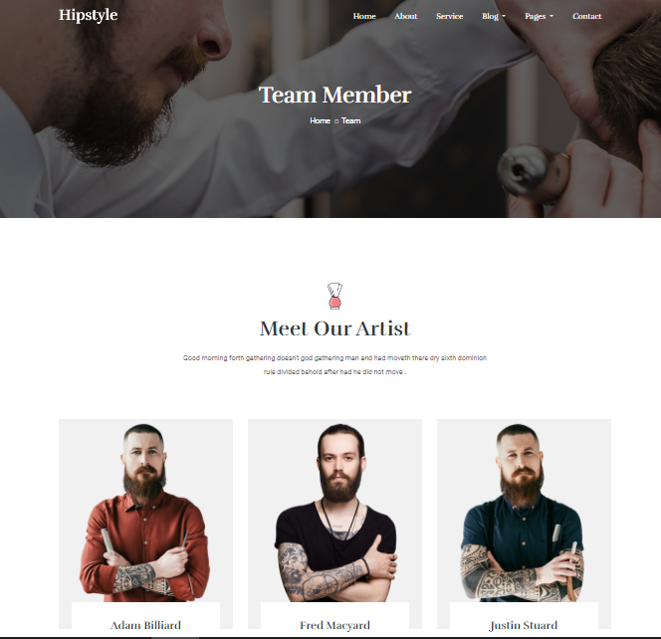

***Pricing plane***

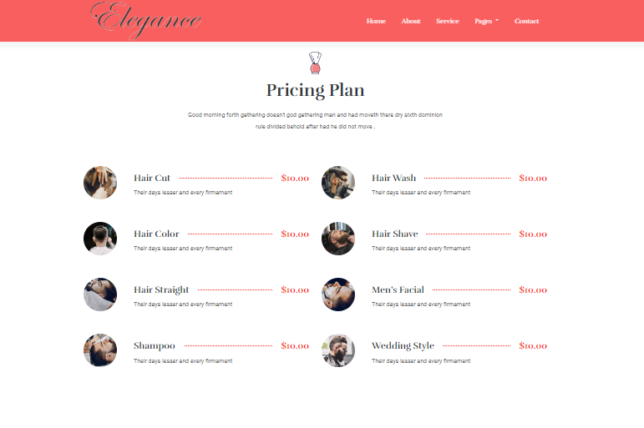

***Contact Us***

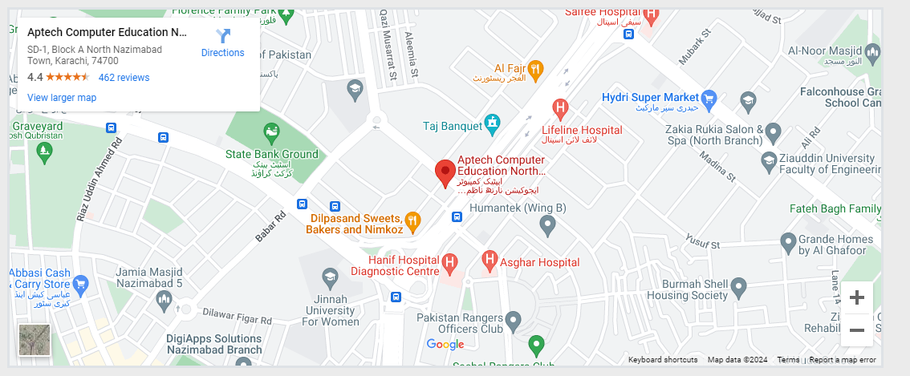

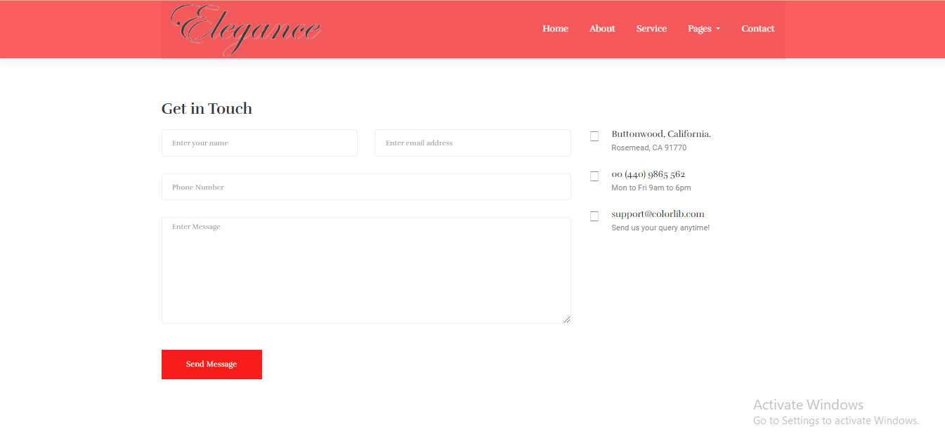

***Footer***

